
Bergstrom eCoolPark Informational Form

Upfitter Information
Company Name: Click or tap here to enter text.
Address: Click or tap here to enter text. City/State/Zip: Click or tap here to enter text.
Contact Name: Click or tap here to enter text. Phone: Click or tap here to enter text.
Contact Email: Click or tap here to enter text.

Vehicle(s) Information
Make: Click or tap here to enter text. Model: Click or tap here to enter text.
Vehicle Refrigerant Type: Choose an item.
VIN: Click or tap here to enter text. Quantity: Click or tap here to enter text.

Make: Click or tap here to enter text. Model: Click or tap here to enter text.
Vehicle Refrigerant Type: Choose an item.
VIN: Click or tap here to enter text. Quantity: Click or tap here to enter text.

System Information
Please select all systems of interest. Specific detail and specifications can be found here: https://bergstrominc.com/us/ecoolpark-systems/
☐ eCoolPark Moon (12 VDC) – 7,600 BTU/hr
☐ eCoolPark Eclipse (24 VDC) – 11,250 BTU/hr
☐ eCoolPark Sun (48 VDC) – 15,000 BTU/hr
☐ eCoolPark XT Moon (12 VDC) – 7,600 BTU/hr
☐ eCoolPark XT Eclipse (24 VDC) – 11,250 BTU/hr
☐ eCoolPark XT Sun (48 VDC) – 15,000 BTU/hr
Note: All high voltage eCoolPark systems require 12 VDC and utilize the vehicle OEM blower. The 12 VDC source must be supported during engine off. See power source section for additional details.

System Mounting Information
Select eCoolPark Unit Mounting Style (eCoolPark XT Only):
☐ Floor/Shelf Mount ☐ Back Wall Mount ☐ Rail Mount
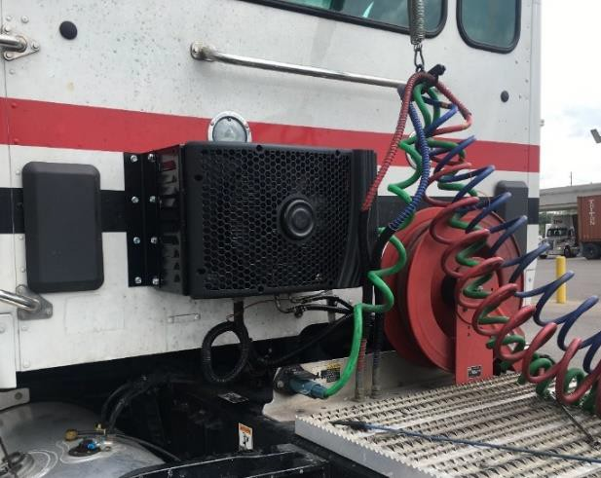
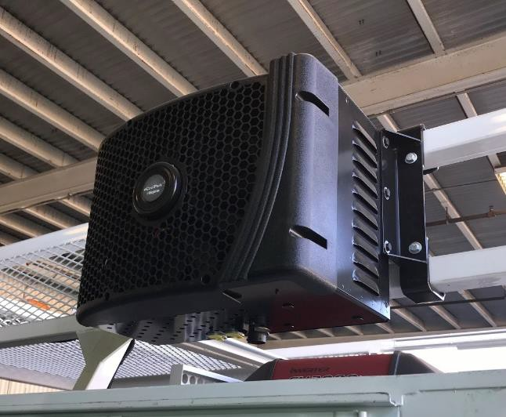
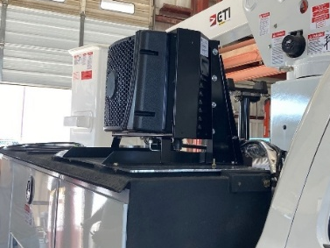

☐ I will create my own bracketry (CAD available upon request)
☐ Unknown (need support from Bergstrom)

Power Source
The power source will be the main variable for the runtime of the system. Extreme attention and thought must be given to accurately size the power source for the application.
Power Source: Choose an item.
Vehicle has automatic engine start/stop feature: ☐
Note: Bergstrom recommends the Dragonfly Dual Flow PowerPack. It is offered through Bergstrom and includes all the necessary components for high voltage support as well at 12 VDC support. If another option is chosen, be aware of the components necessary for proper function and runtime. Power source must simultaneously support high voltage load as well as the 12 VDC load (for OEM blower) while the vehicle engine is off. Additionally, if the source is a battery it will need to be charged during engine on operation. A bi-directional DC-DC converter can accomplish this as well as multiple standard DC-DC converters. Contact Bergstrom for additional explanation and support.

eCoolPark Installation Training
I am interested in eCoolPark training: ☐
I understand there may be a cost associated with training: ☐
Today’s Date: Click or tap to enter a date.
Requested Training Date Approximation (4-8 week lead time): Click or tap to enter a date.

Note: Training overview below. In lieu of training, installation manuals are available online at https://bergstrominc.com/us/manuals-and-support-installation-manuals/. Additionally, an installation video of a basic install is available at https://bergstrominc.com/us/ecoolpark-systems/.

Training Overview
- Identify eCoolPark system models and components contained in the basic kit
- Identify the best location for mounting of the compressor unit
- Complete refrigerant circuit alteration and hose routing
- Complete charging of refrigerant system with leak check
- Complete electrical wiring routing, ECU parameter flash (if necessary), and electrical test.
- Troubleshooting system basics
- Operational procedures
- Instructions on warranty claims and procedures

Customer Agrees with the Following
- Provide at least 1 shop technician with his/her full attention
- Training time of 8-12 hours (will usually split between 2 days)
- Enclosed shop workspace with vehicle lift (for standard eCoolPark systems)
- 110 AC power and all tools in the list on the next page
- Customer will purchase all necessary components for installation
  - Bergstrom system
  - Bergstrom installation kit
  - Mounting brackets
  - System power source (Batteries, power supply, etc.)
  - Any miscellaneous features (solar power, auto stop/start, etc.)

Installation Tools List

- Electrical Tape
- Hose Cutters
- #4 Professional Grade Cable Crimpers
- Work Light
- Torque Wrench up to 150 in/lbs.
- U-barrel Crimpers
- Deutsch Crimpers
- Step Bit
- Refrigerant Hose Clamp Ratcheting Plyers (see note)
- Refrigerant Machine or the Following:
  - Tank of Virgin R-134a/1234yf
  - Refrigerant Scale
  - Vacuum Pump
  - Gauge Set with Hoses
  - Recovery Machine
- Drill Bit Set
- Hole Saws (up to 2”)
- Electric/Air Drill
- Screwdrivers/Assorted Bits (Flat and Phillips)
- Impact Gun
- Air Saw/Jigsaw (Sheet Metal/Steel Cutting)
- Torx Head Bit Set (T20 and T25)
- Metric and SAE Wrenches
- 1/4” and 3/8” Drive Ratchets
- Metric and SAE Socket Set
- Wire Cutters (up to 2/0)
- Terminal Crimpers
- Wire Strippers (up to 2/0)
- Razor Knife
- Painters Tape
- Snake Tool
NOTE:
All refrigerant equipment must be rated for the refrigerant type used in the vehicle.
Ratcheting crimping plyers and eCoolPark programming kit are included in the cost of training (if applicable to requested system)

For Bergstrom Personnel Only:
eCoolPark Unit Part Number: Click or tap here to enter text.
eCoolPark Installation Kit Part Number: Click or tap here to enter text.
eCoolPark Mounting Kit Part Number: Click or tap here to enter text.

Comments: Click or tap here to enter text.

